
SRM Institute of Science and Technology
Mode of Exam
OFFLINE
College of Engineering and Technology
School of Computing
DEPARTMENT OF NETWORKING AND COMMUNICATIONS
SRM Nagar, Kattankulathur – 603203, Chengalpattu District, Tamilnadu
Academic Year: 2022_2023_EVEN
Test: CLAT- 1 Date: 16/02/2023
Course Code & Title:18CSE382T_Forensics and Incident Response Duration: 60 minutes
Year & Sem: III /VI
SET : A Max. Marks: 25

Course Articulation Matrix:
Course Outcomes (CO): |  |  |  |  |  | The learners will be able to:
CO-1 : |  | Acquire the knowledge on basics of procedures for identification, preservation of electronic evidence
Program Outcomes (PO)
1 | 2 | 3 | 4 | 5 | 6 |  | 7 | 8 | 9 | 10 | 11 | 12 | PSO
Engineering Knowledge | Problem Analysis | Design & Development | Analysis, Design, Research | Modern Tool Usage | Society & Culture |  | Environment & Sustainability | Ethics | Individual & Team Work | Communication | Project Mgt. & Finance | Life Long Learning | PSO - 1 |  | PSO - 2 | PSO – 3
3
3-High, 2- Medium, 1-low

Part – A
(10 x 1 = 10 Marks)
Instructions: Answer all
Q. No | Question | Marks | BL | CO | PO | PI Code
1 | Identify the one which is not involved in the phases Initial Response?  - Assemble CSIRT  - Ensure the Incident  - Assessing the Impact  - Measuring data | 1 | 1 | 1 | 1 | 2.5.2
2 | Choose the correct sequence of Cyber Security process cycle.  - Minimize Risk, Identify Threats, Identify Vulnerabilities, Identify Risks  - Identify Threats, Minimize Risk, Identify Risks, Identify Vulnerabilities  - Identify Risks, Identify Threats, Identify Vulnerabilities, Minimize Risk  - Identify Threats, Identify Risks, Identify Vulnerabilities, Minimize Risk | 1 | 1 | 1 | 1 | 1.6.1
3 | Act of attempting to acquire information such as usernames, passwords, and credit card details by masquerading as a trustworthy entity is entitled as  a) email bombing  b) Spamming  c) Cyber stalking  d) Phishing | 1 | 2 | 1 | 1 | 2.8.2
4 | Infer which of the following is the best way to determine your organization state of readiness in order to measure the maturity of a cyber security response.  - The Mandiant Response Readiness Assessment  - Incident readiness assessment  - Cyber security Assessment  - Cyber action assessment | 1 | 2 | 1 | 1 | 1.6.1
5 | Relate the proper method which prevents the incident from spreading across the network.  - Eradication  - Containment  - Recovery  - Mitigation | 1 | 3 | 1 | 1 | 1.6.1
Part – B
( 2 x 4 = 8 Marks)
Instructions: Attend all the Questions
6 | Paraphrase in detail about creating a response toolkit - Linux? | 4 | 2 | 1 | 1 | 2.8.4
7 | Articulate an example when “live acquisition” is necessary. | 4 | 3 | 1 | 1 | 3.7.1
Part – B
( 1 x 12 = 12 Marks)
Instructions: Attend all the Questions
8 | a) Illustrate the concept and provide the steps of Pre-Incident Methodology Process. (10)  b) What are the main elements of an IR POLICY? (2) | 12 | 3 | 1 | 1 | 3.7.1
*Performance Indicators are available separately for Computer Science and Engineering in AICTE examination reforms policy.
Course Outcome (CO) and Bloom’s level (BL) Coverage in Questions

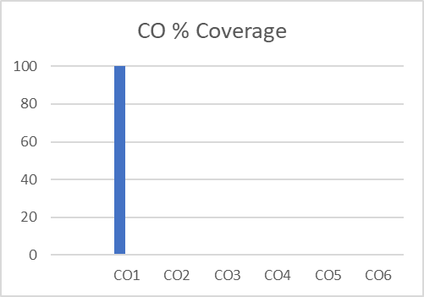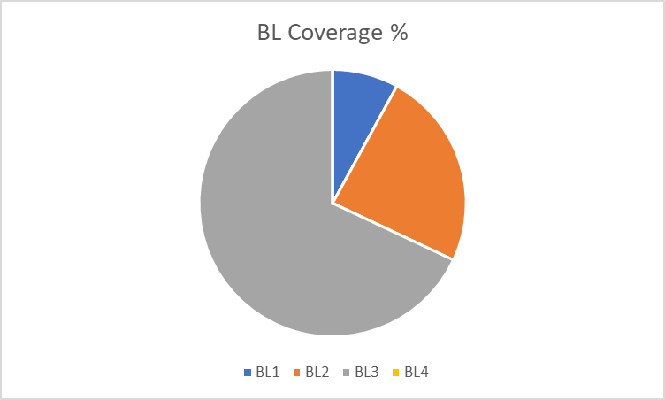

Approved by the Audit Professor/Course Coordinator

